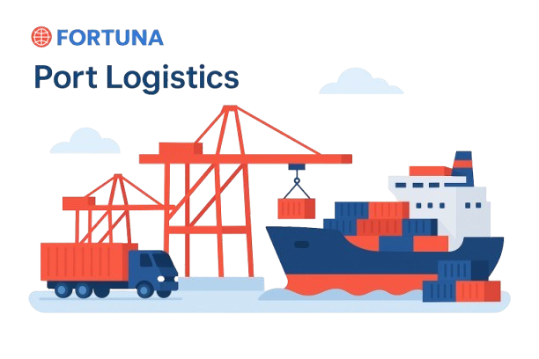

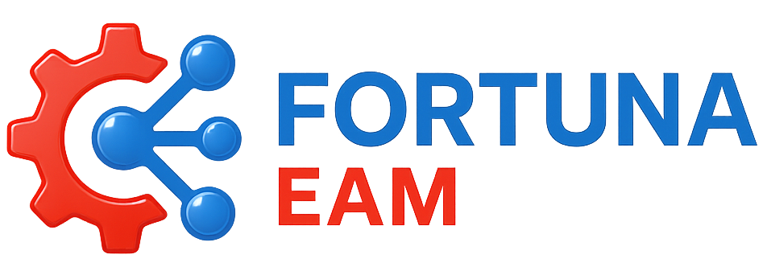

Website: www.fortunaglobalsupplychain.com
E-mail: info@fortunaglobalsupplychain.com

🏢 Company Overview

Fortuna Global Supply Chain Systems is a next-generation enterprise technology company revolutionizing the global logistics and supply chain landscape.
With a vision to create intelligent, transparent, and connected ecosystems, Fortuna blends innovation, data intelligence, and automation to help businesses achieve supply chain excellence.
Established with the belief that efficiency is the new currency, Fortuna empowers organizations to manage operations smarter — from demand planning to last-mile delivery — through real-time insights and seamless digital integration.
We are not just a technology provider; we are partners in transformation — driving global supply chain optimization with precision, performance, and predictive intelligence.

FORTUNA GLOBAL SUPPLY CHAIN SYSTEMS

“The Future of Enterprise Intelligence.”

Fortuna EAM – “Enterprise Asset Management”

Fortuna EAM is a next-generation Enterprise Asset Management platform that enables organizations to manage, monitor, and optimize their physical assets throughout their lifecycle.
It provides a unified view of assets, maintenance operations, performance analytics, and compliance management — helping enterprises reduce downtime, extend asset life, and optimize operational costs.
By combining IoT sensor data, AI-driven maintenance forecasting, and cloud-based collaboration, Fortuna EAM empowers enterprises to make proactive, data-backed asset decisions across their global operations.

Fortuna EAM redefines enterprise asset management through:
- IoT-enabled real-time asset monitoring
- AI-based predictive maintenance forecasting
- Automated work order & service management
- End-to-end lifecycle tracking and analytics
It ensures that assets are not just managed — they are continuously optimized, aligned with business continuity, sustainability, and performance goals.

⚙️ 2. System Architecture
Fortuna EAM is built across five intelligent layers:
1️⃣ IoT & Sensor Integration Layer - Real-time monitoring of equipment , and facility data.
2️⃣ Cloud Infrastructure Layer – Secure SaaS framework hosted on AWS / Azure for global scalability.
3️⃣ AI Intelligence Layer – Predictive forecasting, failure detection, and maintenance forecasting.
4️⃣ Visualization & Collabration Layer – Intuitive dashboards, reports, and mobile app interface.
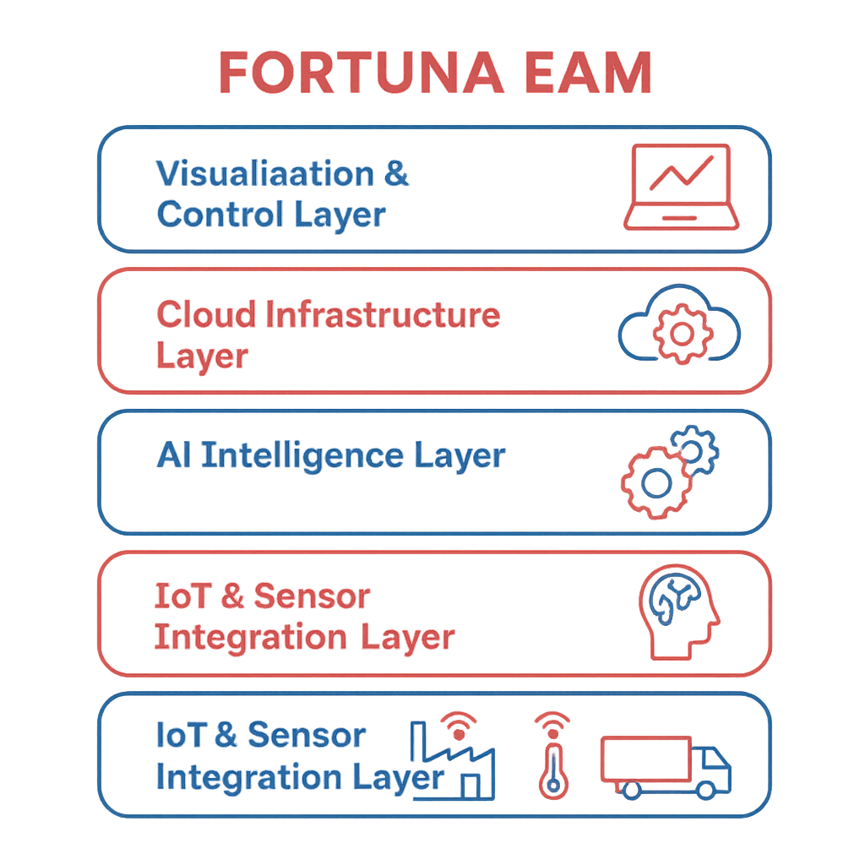

⚙️ 1: Asset Registry & Lifecycle Management

Product Modules, Sub-Modules & Operational Functionality

📚 Submodules:
- Asset Master Data Repository – Stores complete lifecycle records for all assets.
- Hierarchy & Classification Engine – Categorizes assets by type, location, and function.
- Depreciation & Valuation Tracker – Calculates asset value over time.
- Asset Lifecycle Workflow – Tracks acquisition, operation, maintenance, and disposal.

⚙️ Operational Functionality:
- Centralized database for all enterprise assets.
- Tracks ownership, utilization, and asset health status.
- Supports digital on boarding and barcode/RFID asset tagging.
- Real-time updates on operational condition and lifecycle stage.

Product Modules, Sub-Modules & Operational Functionality

📚 Submodules:
- Historical Data Modelling – Learns from past sales, promotions, and seasonal behaviour.
- AI Forecast Generator – Produces short-term, mid-term, and long-term forecasts.
- External Signal Integration – Considers weather, events, and market indexes.
- Forecast Accuracy Tracker – Monitors prediction reliability using MAPE & RMSE.

⚙️ Operational Functionality:
- Automatically collects and cleans data from ERP/POS systems.
- Generates rolling forecasts updated daily or weekly.
- Uses deep learning algorithms to detect new demand trends.
- Provides scenario simulations (“what-if” analysis).

🔧 2: Maintenance Management

📚 Submodules:
- Preventive Maintenance Scheduler – Plans regular service activities.
- Predictive Maintenance Engine – Uses AI to forecast potential failures.
- Work Order Management System – Creates, assigns, and monitors maintenance tasks.
- Technician Mobile Portal – Real-time service updates from field operations.

⚙️ Operational Functionality:
- IoT-based failure prediction through sensor readings and analytics.
- Automated scheduling of preventive and predictive maintenance.
- Mobile-first field management for technicians.
- Reduced downtime through proactive alerts and scheduling optimization.

📊 3: Performance & Reliability Analytics

📚 Submodules:
- KPI Dashboard – Displays uptime, MTBF (Mean Time Between Failures), and OEE.
- Anomaly Detection Engine – Identifies irregular performance trends.
- Cost & Efficiency Tracker – Monitors maintenance cost vs asset output.
- Predictive Trend Analysis – Suggests replacement or overhaul timelines.

⚙️ Operational Functionality:
- Provides visual analytics on asset performance and reliability.
- Uses AI to predict failure trends and optimize maintenance spend.
- Supports executive dashboards with customizable KPIs.

⚙️ 4: IoT Integration & Real-Time Monitoring

📚 Submodules:
- IoT Device Gateway – Connects sensors, PLCs, and machine controllers.
- Condition Monitoring Dashboard – Displays temperature, vibration, and runtime.
- Alert & Threshold Engine – Auto-triggers maintenance requests on anomalies.
- Data Streaming Service – Transfers real-time telemetry into the EAM database.

⚙️ Operational Functionality:
- Collects live data from connected devices across factories or fleets.
- Generates predictive alerts before breakdowns occur.
- Visualizes IoT data on centralized dashboards.
- Enhances asset visibility across multiple facilities.

⚙️ 5: Work Order & Resource Management

📚 Submodules:
- Work Request Portal – Enables users to submit repair/service requests.
- Task Allocation Engine – Assigns technicians based on skill and location.
- Inventory & Spare Parts Sync – Integrates with Fortuna SIMS for part availability.
- SLA & Completion Tracker – Monitors adherence to service-level commitments.

⚙️ Operational Functionality:
- End-to-end automation of work order lifecycle.
- Tracks spare part usage and costs per job.
- Ensures faster turnaround through technician routing optimization.
- Provides analytics on work efficiency and response time.

🛡️ 6: Compliance & Safety Management

📚 Submodules:
- Regulatory Compliance Dashboard – Manages audits, ISO standards, and certifications.
- Incident Reporting Engine – Tracks safety incidents and corrective actions.
- Risk Assessment Matrix – AI-based hazard probability analysis.
- Document Control Hub – Central repository for maintenance and safety documentation.

⚙️ Operational Functionality:
- Automates compliance checks and documentation for safety audits.
- Provides alerts for license expirations and inspection schedules.
- Enhances EHS (Environment, Health & Safety) visibility.
- Supports audit trails for government and corporate reporting.

🔗 7: Integration & Data Synchronization Layer

📚 Submodules:
- ERP & Finance Integration – Links asset depreciation and cost data to ERP systems.
- SIMS & TMS Integration – Connects asset usage and transport equipment data.
- IoT & ConnectHub Sync – Ensures unified communication across the Fortuna suite.
- External Vendor APIs – For OEM, service contractors, or warranty tracking.

⚙️ Operational Functionality:
- Real-time synchronization between EAM and other Fortuna systems.
- Enables unified reporting across supply chain and asset lifecycle.
- Ensures consistency in asset-related financial data.
- Simplifies collaboration with third-party service partners.

📈 Functional Workflows

A. Predictive Maintenance Workflow
- IoT Sensor Detects Anomaly
- AI Predictive Engine Forecasts Failure
- Auto-Generate Work Order
- Technician Notification
- Repair Execution
- Asset Health Updated

B. Asset Lifecycle Workflow
- Asset Creation / Procurement From Vendors.
- Operation & Monitoring
- Preventive Maintenance
- Depreciation & Cost Tracking
- End-of-Life Disposal
- Data Archived to Analytics

Fortuna EAM Advantages
Feature | Business Value
IoT-Based Predictive Maintenance | Reduces Un Planned Down Time.
End-to-End Lifecycle Management | Maximizes asset utilization
AI-Driven Failure Forecasting | Enables proactive maintenance planning
Centralized Asset Visibility | Enhances accountability and control.
Integration Across Fortuna Suite | Ensures unified operational insights
Regulatory & Safety Automation | Simplifies audits and compliance

Automotive & Industrial Manufacturing

🏭 Industries Served


FGSCM - supports the automotive sector with advanced logistics planning, vendor coordination, and predictive maintenance scheduling. From global parts movement to plant-level production support, our systems reduce lead times and enhance supply chain agility

Ports & Logistics
•


Fortuna supports the automotive sector with advanced logistics planning, vendor coordination, and predictive maintenance scheduling. From global parts movement to plant-level production support, our systems reduce lead times and enhance supply chain agility

Food & Beverage Distribution
•


Freshness and safety are at the heart of Food & Beverage -supply chains. We enable end-to-end visibility with IoT-driven tracking, automated quality checks, and predictive demand planning—ensuring traceability from farm to fork.

Fashion & Retail Industry
•


With High seasonal demand & agile supply chain Planning, Fortuna will empowers retailers with faster replenishment & reduces stock outs

Pharma & Healthcare
•


Medical safety and regulatory compliance are non-negotiable. We provide automated solutions for cold chain logistics, product traceability, and compliance monitoring—ensuring life-saving medicines and healthcare products reach destinations safely and efficiently.

E-Commerce & Distributional Channels
•


In a fast-moving E-Com world, speed and efficiency are critical. Our platforms enable automated order management, demand forecasting, and last-mile delivery optimization—ensuring customers receive the right products, at the right time, every time.

🏛️ Corporate Identity


Headquarters: Visakhapatnam, Andhra Pradesh, India
Website: www.fortunaglobalsupplychain.com
Email: info@fortunaglobalsupplychain.com

